Subject: Software Requirements
Title: Progress Test 1
Content: Chapter 1,2,3,4
Time: 30’
Number of question: 32/60

QN=1 | Which of the following is the system that exists before the machine is built into it?
a. | system-exist
b. | system-to-be
c. | system-to-be-next
d. | system-as-is
e.
f.
ANS: | D
PTS: | 1
CHAPTER: | 1
MIX CHOICES: | YES

QN=2 | Which of the following is the system as it should be when the machine will be built and operated in it?
a. | system-exist
b. | system-to-be
c. | system-to-be-next
d. | system-as-is
e.
f.
ANS: | B
PTS: | 1
CHAPTER: | 1
MIX CHOICES: | YES

QN=3 | Components pertaining to the machine's surrounding world will form
a. | Environment of system-to-be
b. | Environment of system-as-is
c. | Environment of software-as-is
d. | Environment of software-to-be
e.
f.
ANS: | D
PTS: | 1
CHAPTER: | 1
MIX CHOICES: | YES

QN=4 | Requirements engineering is
a. | the processes involved in developing system design
b. | the processes involved in developing system documents
c. | the processes involved in developing and verifying system
d. | the processes involved in developing system requirements
e.
f.
ANS: | D
PTS: | 1
CHAPTER: | 1
MIX CHOICES: | YES

QN=5 | ____________refer to "the contextual reasons for a new version of a system must be made explicit in terms of objectives" to be satisfied by
a. | the WHAT dimension
b. | the WHO dimension
c. | the WHY dimension
d. | the HOW dimension
e.
f.
ANS: | C
PTS: | 1
CHAPTER: | 1
MIX CHOICES: | YES

QN=6 | Which of the following is NOT a stage of requirement engineering process?
a. | Domain understanding and elicitation
b. | Evaluation and Negotiation
c. | Specification and documentation
d. | Requirement Traceability
e.
f.
ANS: | D
PTS: | 1
CHAPTER: | 1
MIX CHOICES: | YES

QN=7 | _______ addresses the assignment of responsibilities for achieving the objectives, services, and constraints among the components of the system-to-be
a. | the WHAT dimension
b. | the WHO dimension
c. | the WHY dimension
d. | the HOW dimension
e.
f.
ANS: | B
PTS: | 1
CHAPTER: | 1
MIX CHOICES: | YES

QN=8 | ________ Statements state properties about the system that hold regardless of how the system behaves. Such properties hold typically because of some natural law or physical constraint.
a. | Descriptive
b. | Description
c. | Prescriptive
d. | Prescription
e.
f.
ANS: | A
PTS: | 1
CHAPTER: | 1
MIX CHOICES: | YES

QN=9 | The following statement is an example of ____ statement:  - The same book copy can not be borrowed by two different people at the same time.
a. | Prescriptive
b. | Descriptive
c. | Description
d. | Prescription
e.
f.
ANS: | B
PTS: | 1
CHAPTER: | 1
MIX CHOICES: | YES

QN=10 | __________statements state desirable properties about the system that may hold or not depending on how system behaves
a. | Descriptive
b. | Description
c. | Prescriptive
d. | Prescription
e.
f.
ANS: | C
PTS: | 1
CHAPTER: | 1
MIX CHOICES: | YES

QN=11 | __________is the requirement document item, which cannot be realistically implemented within assigned budget, schedule, or development platform.
a. | Omission
b. | Inadequacy
c. | Unmeasurability
d. | Unfeasibility
e.
f.
ANS: | D
PTS: | 1
CHAPTER: | 1
MIX CHOICES: | YES

QN=12 | In a _________ project, a brand new software solution is built from scratch to address problems with the system-as-is and exploit new opportunities from technology evolution or market conditions.
a. | greenfield
b. | customer-driven
c. | brownfield
d. | market-driven
e.
f.
ANS: | A
PTS: | 1
CHAPTER: | 1
MIX CHOICES: | YES

QN=13 | In a_______ project, a software solution is developed to address the actual needs of one specific customer in the context of one specific organisation.
a. | greenfield
b. | customer-driven
c. | brownfield
d. | market-driven
e.
f.
ANS: | B
PTS: | 1
CHAPTER: | 1
MIX CHOICES: | YES

QN=14 | All of the following statements about the impacts of the requirements document on other software artifacts are correct, EXCEPT?
a. | The requirements documents have impacts on user manual and versus.
b. | The requirements document is an essential input for architectural design activities.
c. | The requirements document provides the ultimate reference for quality assurance activities.
d. | The requirements document, possibly in summarized form, is an important component of the software documentation.
e.
f.
ANS: | A
PTS: | 1
CHAPTER: | 1
MIX CHOICES: | YES

QN=15 | The following are uses of requirements taxonomies, EXCEPT?
a. | More specific definition of what requirements are in specific classes
b. | More semantic characterization of requirements
c. | Requirement elicitation/analysis can be guided by taxonomy browsing
d. | More specific definition of how the system should be constructed.
e.
f.
ANS: | D
PTS: | 1
CHAPTER: | 1
MIX CHOICES: | YES

QN=16 | ______________ techniques reply more on specific types of artefact to support the elicitation process
a. | Artefact-driven
b. | Stakeholder-driven
c. | Stakeholder analysis
d. | Interacting with stakeholders
e.
f.
ANS: | A
PTS: | 1
CHAPTER: | 2
MIX CHOICES: | YES

QN=17 | The following criteria are used for selecting stakeholders, EXCEPT?
a. | Relevant position in the organization
b. | Level of domain expertise
c. | Ability of creating prototypes for system-to-be
d. | Effective role in making decisions about the system-to-be
e.
f.
ANS: | C
PTS: | 1
CHAPTER: | 2
MIX CHOICES: | YES

QN=18 | Which of the following is a skill required for interacting with stakeholders?
a. | Knowledge reformulation
b. | Technical skill
c. | Requirement documentation skill
d. | Imagine skill
e.
f.
ANS: | A
PTS: | 1
CHAPTER: | 2
MIX CHOICES: | YES

QN=19 | Which of the following can be helpful for eliciting non-functional requirements related to usability, performance, and costs?
a. | Questionnaires
b. | Data Collection
c. | Background study
d. | Knowledge reuse
e.
f.
ANS: | B
PTS: | 1
CHAPTER: | 2
MIX CHOICES: | YES

QN=20 | ________ shows aspects related to software functionalities.
a. | A software user prototypes
b. | A functional prototypes
c. | A system user interface prototypes
d. | A system screen mock-ups
e.
f.
ANS: | B
PTS: | 1
CHAPTER: | 2
MIX CHOICES: | YES

QN=21 | Which of the following is NOT a stakeholder-driven elicitation technique?
a. | Interview
b. | Group sessions
c. | Observation and ethnographic studies
d. | Stakeholder analysis
e.
f.
ANS: | D
PTS: | 1
CHAPTER: | 2
MIX CHOICES: | YES

QN=22 | The following are obstacles to effective knowledge acquisition, EXCEPT?
a. | Distributed and conflicting knowledge sources
b. | Difficult access to sources
c. | Interacting with stakeholders
d. | Obstacles to good communication
e.
f.
ANS: | C
PTS: | 1
CHAPTER: | 2
MIX CHOICES: | YES

QN=23 | ________ shows static and dynamic aspects of user-software interaction.
a. | A software functional prototypes
b. | A system functional prototypes
c. | A user interface prototypes
d. | Screen mock-ups
e.
f.
ANS: | C
PTS: | 1
CHAPTER: | 2
MIX CHOICES: | YES

QN=24 | Which of the following is used to explore how the system-as-is is running?
a. | Scenarios & storyboard
b. | Questionnaires
c. | Data Collection
d. | Card sort & repertory grid
e.
f.
ANS: | A
PTS: | 1
CHAPTER: | 2
MIX CHOICES: | YES

QN=25 | Which of the following is NOT a concept-driven acquisition technique?
a. | Interview
b. | Repertory grids
c. | Card sorts
d. | Conceptual laddering
e.
f.
ANS: | A
PTS: | 1
CHAPTER: | 2
MIX CHOICES: | YES

QN=26 | Which of the following is NOT a strength of group sessions technique?
a. | Group sessions is less formal interactions than interviews. It may reveal hidden aspects of the system (as-is or to-be)
b. | Group sessions is potentially wider exploration of issues & ideas
c. | Group sessions can be used to resolve conflicts
d. | Group sessions can be used to get contextualization of information.
e.
f.
ANS: | D
PTS: | 1
CHAPTER: | 2
MIX CHOICES: | YES

QN=27 | Which of the following techniques focuses on task elicitation in the system-as-is to acquire contextualization of information?
a. | Observation & ethnographic studies
b. | Interview
c. | Group session
d. | Questionnaires
e.
f.
ANS: | A
PTS: | 1
CHAPTER: | 2
MIX CHOICES: | YES

QN=28 | We should follow the items in interview guidelines as below, EXCEPT?
a. | Identify the right interviewee sample for full coverage of issues.
b. | Come prepared, to focus on right issue at right time
c. | Centre the interview on the interviewee’s work & concerns
d. | Do not keep control over the interview
e.
f.
ANS: | D
PTS: | 1
CHAPTER: | 2
MIX CHOICES: | YES

QN=29 | All of the followings are transposition mechanisms used in Knowledge reuse technique to transpose the retrieved knowledge fragments into vocabulary of the target system, EXCEPT?
a. | Specialization
b. | Instantiation
c. | Reformulation
d. | Transformation
e.
f.
ANS: | D
PTS: | 1
CHAPTER: | 2
MIX CHOICES: | YES

QN=30 | Which of the following is NOT a disadvantage of Prototypes & Mock-up technique?
a. | Prototypes does not cover all aspects
b. | Prototypes can be misleading, set expectations too high
c. | ‘Quick-and-dirty’ code, hard to reuse for software development
d. | Prototypes are not helpful to clarify requirements and elicit hidden ones
e.
f.
ANS: | D
PTS: | 1
CHAPTER: | 2
MIX CHOICES: | YES

QN=31 | The target of ________ is a set of low-risks, conflict-free requirements and assumptions that stakeholders agree on.
a. | Domain Understanding and Elicitation
b. | Requirements Evaluation
c. | Requirements Specification
d. | Requirements Validation
e.
f.
ANS: | B
PTS: | 1
CHAPTER: | 3
MIX CHOICES: | YES

QN=32 | Which of the following items is NOT a type of inconsistency of requirements?
a. | Terminology clash
b. | Designation clash
c. | Inconsistency management
d. | Structure clash
e.
f.
ANS: | C
PTS: | 1
CHAPTER: | 3
MIX CHOICES: | YES

QN=33 | _________________. These are statements that can not be satisfied when taken together; their logical conjunction evaluates to false in all circumstances.
a. | Weak conflict or divergence
b. | Designation clash
c. | Structure clash
d. | Strong conflict
e.
f.
ANS: | D
PTS: | 1
CHAPTER: | 3
MIX CHOICES: | YES

QN=34 | Risk management process contains the following stages, EXCEPT?
a. | Risk identification
b. | Risk assessment
c. | Risk resolution
d. | Risk control
e.
f.
ANS: | C
PTS: | 1
CHAPTER: | 3
MIX CHOICES: | YES

QN=35 | The goals of risk assessment is to assess likelihood of risks, _________, likelihood of consequences, to control high-priority risks
a. | risk severity
b. | risk resolution
c. | risk control
d. | risk management
e.
f.
ANS: | A
PTS: | 1
CHAPTER: | 3
MIX CHOICES: | YES

QN=36 | The goals of _______ is to reduce high-exposure risks through countermeasures
a. | Risk control
b. | Risk assessment
c. | Risk register
d. | Risk identification
e.
f.
ANS: | A
PTS: | 1
CHAPTER: | 3
MIX CHOICES: | YES

QN=37 | Which of the following items is NOT a step in the process of risk management with DDP for RE?
a. | Elaborate the Impact matrix
b. | Elaborate the Effectiveness matrix
c. | Determine optimal balance risk reduction vs. countermeasure cost
d. | Quantitative reasoning for evaluating options
e.
f.
ANS: | D
PTS: | 1
CHAPTER: | 3
MIX CHOICES: | YES

QN=38 | Assume that risk (r) only cause one consequence (c).  Give Likelihood (c) = 0.7, Severity (c) = 5, cost(cm) = 0.5. Exposure(r) = ?
a. | 1.15
b. | 3.5
c. | 2.5
d. | 0.35
e.
f.
ANS: | B
PTS: | 1
CHAPTER: | 3
MIX CHOICES: | YES

QN=39 | Which of the following are NOT exploring risk countermeasures techniques?
a. | Using elicitation techniques
b. | Reusing known countermeasures
c. | Using risk reduction tactics
d. | Using design methodologies
e.
f.
ANS: | D
PTS: | 1
CHAPTER: | 3
MIX CHOICES: | YES

QN=40 | The following sample statement is a ________ statement.  The staff's viewpoint in our library system might state, 'a borrower should return a borrowed book copy within two weeks'.  A stakeholder having the borrower's viewpoint might state, 'a borrower should keep a borrowed book copy as long as he or she needs it'.
a. | Strong conflict
b. | Weak conflict or divergence
c. | Structure clash
d. | Designation clash
e.
f.
ANS: | B
PTS: | 1
CHAPTER: | 3
MIX CHOICES: | YES

QN=41 | Give Evaluation Criteria (NFRs) of scheduling Meeting program to quantitative reasoning for evaluation options as below:  - Fast responds: (Significance weighting: 0.30; Option 1 score: 0.40)  - Realizable response: (Significance weighting: 0.50; Option 1 score: 0.80)  - Minimal inconvenience: (Significance weighting: 0.10; Option 1 score: 0.30)  Which of the following is a total score of option 1?
a. | 0.52
b. | 0.55
c. | 0.57
d. | 0.5
e.
f.
ANS: | B
PTS: | 1
CHAPTER: | 3
MIX CHOICES: | YES

QN=42 | Which of the following items is NOT a step of Value-cost prioritization process?
a. | Estimate relative contribution of each requirement to project’s value
b. | Estimate relative contribution of each requirement to project’s cost
c. | Plot contributions on value-cost diagram
d. | Build comparison matrix
e.
f.
ANS: | d
PTS: | 1
CHAPTER: | 3
MIX CHOICES: | YES

QN=43 | All of the following are main evaluation criteria for selecting preferred countermeasures, EXCEPT?
a. | The contribution to critical non-functional requirements.
b. | The contribution to resolution of other risks
c. | The cost-effectiveness
d. | The contribution to the core functional requirements
e.
f.
ANS: | d
PTS: | 1
CHAPTER: | 3
MIX CHOICES: | YES

QN=44 | Which of the following is NOT a risk-reduction tactics?
a. | Reduce risk likelihood
b. | Avoid risk consequence
c. | Mitigate risk consequence
d. | Using elicitation techniques
e.
f.
ANS: | d
PTS: | 1
CHAPTER: | 3
MIX CHOICES: | YES

QN=45 | Which of the following type of risks can we use component inspection technique to identify?
a. | Product-related risks
b. | Process-related risks
c. | Development risks
d.
e.
f.
ANS: | a
PTS: | 1
CHAPTER: | 3
MIX CHOICES: | YES

QN=46 | Which of the following are NOT differences of problem diagram comparing with context diagram?
a. | A rectangle with double vertical stripe represent the machine to be built
b. | A rectangle with a single vertical stripe represent the component to be designed
c. | Shared phenomena are controlled/monitored by components
d. | An interface can be declared separately the exclamation mark after a component name prefixing
e.
f.
ANS: | c
PTS: | 1
CHAPTER: | 4
MIX CHOICES: | YES
QN=47 | Which of the following is A context diagram that can be further detailed by indicating explicitly which component controls a shared phenomena, which component constitutes the machine needs to be built, and which components are affected by which requirements?
a. | context diagram
b. | Frame diagram
c. | Problem diagram
d. | state machine diagram
e. | entity-relationship diagram
f.
ANS: | C
PTS: | 1
CHAPTER: | 4
MIX CHOICES: | YES

QN=48 | A_________ is captured by a sequence of state transitions for the system items that the component control
a. | Behavior
b. | State
c. | SM state transition
d. | SM trace
e. | SM State
f.
ANS: | A
PTS: | 1
CHAPTER: | 4
MIX CHOICES: | YES

QN=49 | 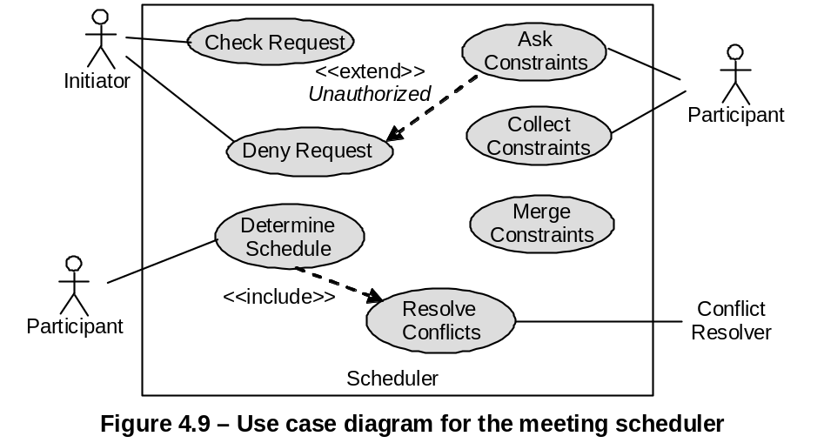  In Figure 4.9 [file: Figure-4.9.jpg], “DenyRequest - <<extend>> - AskConstraints” means:
a. | DenyRequest is a sub-operation of AskConstraints.
b. | DenyRequest is an alternative operation of AskConstraints.
c. | DenyRequest is a variant operation of AskConstraints, when the condition named Unauthorized holds.
d. | None of the others
e.
f.
ANS: | C
PTS: | 1
CHAPTER: | 4
MIX CHOICES: | YES

QN=50 | The data-activity duality principle requires actigram items to have some __________ in a datagram, and vice versa.
a. | Countermeasures
b. | Counterparts
c. | Opponents
d. | Companions
e.
f.
ANS: | B
PTS: | 1
CHAPTER: | 4
MIX CHOICES: | YES

QN=51 | State machine diagram is made by two core constructs:
a. | States, Relationships
b. | States, Associations
c. | States, Transitions
d. | States, Operations
e.
f.
ANS: | C
PTS: | 1
CHAPTER: | 4
MIX CHOICES: | YES

QN=52 | Actigrams (Datagrams) declare activities (data) by their input/output data (producing/consuming activities) and interconnect them through data (___________) dependency links.
a. | Action
b. | Value
c. | Data
d. | Control
e.
f.
ANS: | D
PTS: | 1
CHAPTER: | 4
MIX CHOICES: | YES

QN=53 | ER diagram is made from three core constructs: entities, __________ and relationships.
a. | Classes
b. | Methods
c. | Objects
d. | Attributes
e.
f.
ANS: | D
PTS: | 1
CHAPTER: | 4
MIX CHOICES: | YES

QN=54 | In Figure 4.9 [file: Figure-4.9.jpg], “DetermineSchedule - <<include>> - ResolveConflicts” means:
a. | ResolveConflicts is a ‘sub-operation’ of DetermineSchedule.
b. | ResolveConflicts is an ‘alternative-operation’ of DetermineSchedule.
c. | ResolveConflicts is a ‘variant-operation’ of DetermineSchedule.
d.
e.
f.
ANS: | A
PTS: | 1
CHAPTER: | 4
MIX CHOICES: | YES

QN=55 | 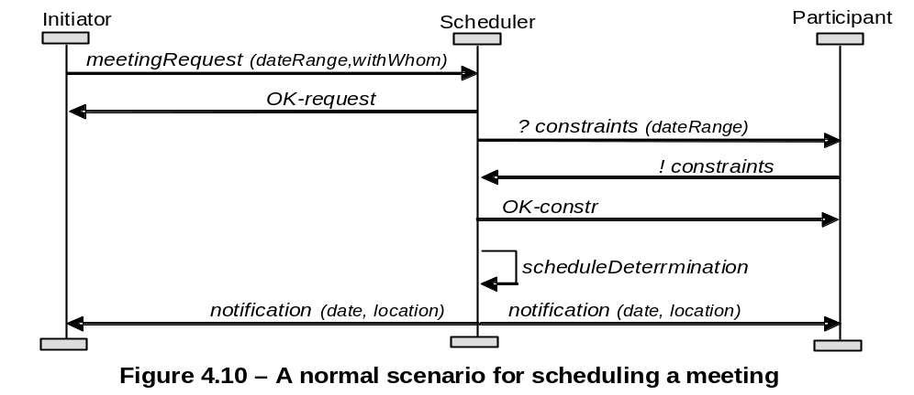  Figure 4.10 [file: Figure-4.10.jpg] shows an Event Trace Diagram specifying a meeting scheduling scenario. The first event is meetingRequest, ________ by an Initiator instance and _________ by a Scheduler instance.
a. | controlled/monitored
b. | monitored/controlled
c. | requested/responded
d. | responded/requested
e.
f.
ANS: | A
PTS: | 1
CHAPTER: | 4
MIX CHOICES: | YES

QN=56 | In state machine diagram, the event occurrence is a ________ condition for transition firing, whereas a guard is a ________ condition for firing.
a. | sufficient/necessary
b. | necessary/sufficient
c.
d.
e.
f.
ANS: | A
PTS: | 1
CHAPTER: | 4
MIX CHOICES: | YES

QN=57 | 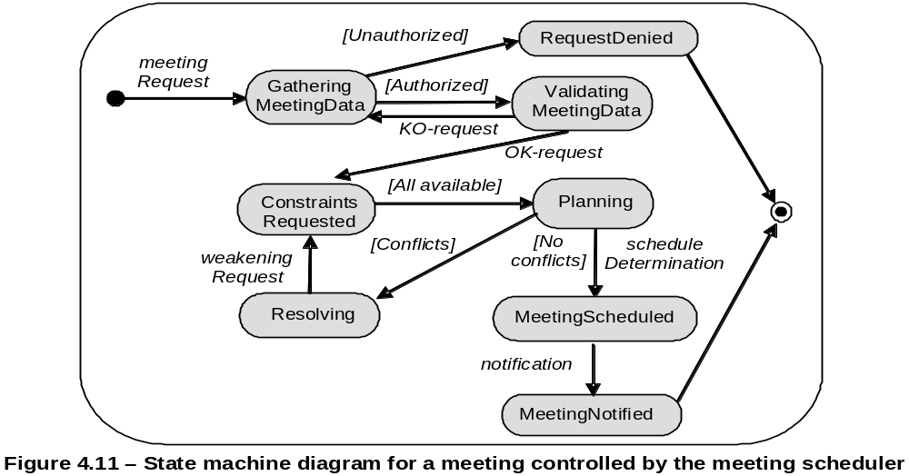  In figure 4.11 [file: Figure-4.11.jpg], the “Planning” state (source state) changes to “MeetingScheduled” state (target state) if __________ (the event) occurs and only if _________ (the guard condition) is true.
a. | scheduleDetermination/[No conflicts]
b. | [No conflicts]/scheduleDetermination
c.
d.
e.
f.
ANS: | A
PTS: | 1
CHAPTER: | 4
MIX CHOICES: | YES

QN=58 | Which of the following specifies all the operations that a system component is required to perform, possibly under a particular condition, in response to a particular input stimulus?
a. | A use-case diagram
b. | An event trace diagram
c. | An R-net diagram
d. | A SADT diagram
e.
f.
ANS: | c
PTS: | 0.5
CHAPTER: | 4
MIX CHOICES: | YES

QN=59 | Which of the followings captures the activities and data in the system (system-to-be or system-as-is), these diagrams allow these activities and data to be documented in a graphical way?
a. | SADT diagrams
b. | Dataflow diagrams
c. | Entity-relationship diagrams
d. | Context diagrams
e.
f.
ANS: | A
PTS: | 1
CHAPTER: | 4
MIX CHOICES: | YES

QN=60 | Which of the following is a standard technique for structuring complex if-then condition?
a. | Using stylistic rules
b. | Using decision table
c. | Using predefined statement templates
d. | Using grouping rules
e.
f.
ANS: | b
PTS: | 1
CHAPTER: | 4
MIX CHOICES: | YES

